BIA 654 B: Experimental Design II

**Ephraim Schoenbrun**

CWID: 104-20-702

Date of Submission: **March 5, 2017**

Assignment:

**Assignment #6**

# **Ethical Conduct**

|  |
| --- |
| The following statement is printed in the Stevens Graduate Catalog and applies to all students taking Stevens courses, on and off campus.  “Cheating during in-class tests or take-home examinations or homework is, of course, illegal and immoral. A Graduate Academic Evaluation Board exists to investigate academic improprieties, conduct hearings, and determine any necessary actions. The term ‘academic impropriety’ is meant to include, but is not limited to, cheating on homework, during in-class or take home examinations and plagiarism.”  Consequences of academic impropriety are severe, ranging from receiving an “F” in a course, to a warning from the Dean of the Graduate School, which becomes a part of the permanent student record, to expulsion.  *Reference: The Graduate Student Handbook, Academic Year 2003-2004 Stevens*  *Institute of Technology, page 10.*  Consistent with the above statements, all homework exercises, tests and exams that are designated as individual assignments MUST contain the following signed statement before they can be accepted for grading. ____________________________________________________________________  I pledge on my honor that I have not given or received any unauthorized assistance on this assignment/examination. I further pledge that I have not copied any material from a book, article, the Internet or any other source except where I have expressly cited the source.  Signature: Date: March 5, 2017  Please note that assignments in this class may be submitted to [www.turnitin.com](http://www.turnitin.com/), a web-based anti-plagiarism system, for an evaluation of their originality. |

1. The makers of “Cats Love It” cat litter are facing a serious problem. Retail customers are reporting that cartons of the firm’s premium brand cat litter are leaking the product onto store shelves. The company realizes that while cat lovers are used to cleaning stray sprays of litter tracked through the house, they are not willing to put up with cartons that leak on the way home. Management has determined that the problem is with the carton-sealing process. Cartons are filled and sealed on a production line run by 20 workers. The company decides to perform 3-factor factorial experiment. A run consists of filling and sealing 200 cartons. The factors to be tested and levels of each are shown below.

* **Factor A** is line speed with the minus level at 22 cartons per minute and the plus level at 30 cartons per minute.
* **Factor B** is the pressure applied by the gluing machine, with the minus level being lower pressure and the plus level being higher pressure.
* **Factor C** is the amount of glue used, with the plus level being the current amount and the minus level being 40% less glue. The response is the proportion (%) of cartons that leak, whose values are observed as 8, 45, 47, 10, 8, 40, 41, 8, listed in the standard order.

1. Make the design matrix (with ‘+’ and ‘–’ symbols) that includes main effects and two- and three factor interactions.
2. What are the estimated main effects of factor A and B? What is the estimated AC interaction?

|  |  |  |  |  |  |  |  |  |
| --- | --- | --- | --- | --- | --- | --- | --- | --- |
|  | A | B | C | AB | AC | BC | ABC | Response |
| Treatment 1 | - | - | - | + | + | + | - | 8 |
| Treatment 2 | + | - | - | - | - | + | + | 45 |
| Treatment 5 | - | - | + | + | - | - | + | 8 |
| Treatment 6 | + | - | + | - | + | - | - | 40 |
| Treatment 3 | - | + | - | - | + | - | + | 47 |
| Treatment 4 | + | + | - | + | - | - | - | 10 |
| Treatment 7 | - | + | + | - | - | + | - | 41 |
| Treatment 8 | + | + | + | + | + | + | + | 8 |
|  | -0.25 | 1 | -3.25 |  |  | 0.25 |  |  |

1. Display the effects graphically through main effects of C and interaction plots for BC and AC.

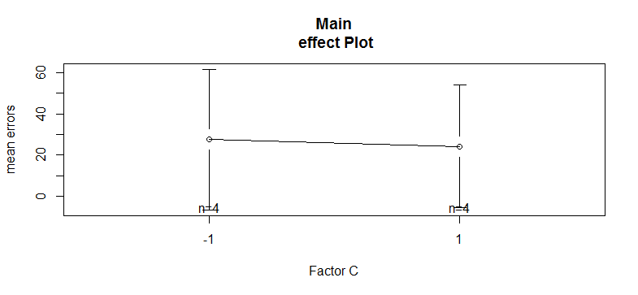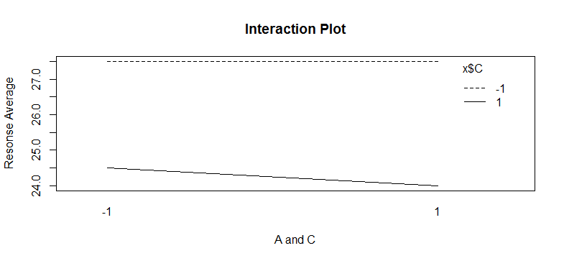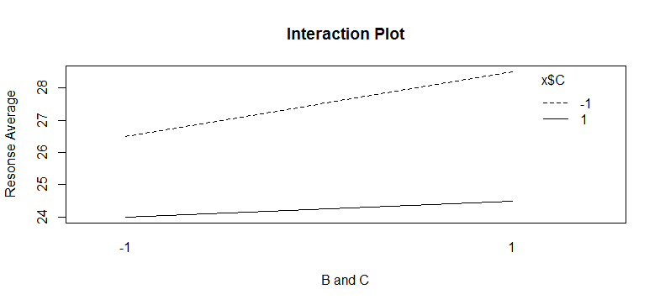

|  |  |  |  |
| --- | --- | --- | --- |
| Property | A | B | C |
| 1 | 90 | 93 | 92 |
| 2 | 94 | 96 | 88 |
| 3 | 91 | 92 | 84 |
| 4 | 85 | 88 | 83 |
| 5 | 88 | 90 | 87 |

* 1. Suppose the three real estate appraisers independently examined each of five properties chosen at random from a particular neighborhood and gave appraised values. The manager of the appraisal service that employs them suspects that systematic differences among their methods of appraisal are causing undesirable inconsistencies in appraised values provided by her service. The issue is whether there are, in fact, systematic differences among the values reported by the three appraisers. The data, APPRAISED VALUES (In thousands of dollars), are shown below.

Question: What kind of statistical analysis should you perform? Choose from: (Two sample ttest, pairwise t-test, One-way ANOVA, One-way ANOVA with block, Two-way ANOVA, Factorial design). If your answer is One-way ANOVA with block, which variable does play a role of block?

**Since you are only comparing one factor – the accuracy of appraisal – with more than two means, then you would choose a one-way ANOVA. Since there may be variations between the individual houses that are chosen, it will impact the variation in appraisals and you would block each property accordingly and randomize the appraisal trials within each block.**

* 1. Suppose each of 4 Chardonnay wines of the same vintage was judged by 5 judges. Each wine was blinded and given to each judge in randomized order. The wines were scored on a 40-point scale, with higher scores meaning better wine. Based on those scores, we want to test whether there is a difference between the 4 Chardonnay wines in mean scores.

Question: What kind of statistical analysis should you perform? Choose: (Two sample t-test, pairwise t-test, One-way ANOVA, One-way ANOVA with block, Two-way ANOVA, Factorial design). If your answer is One-way ANOVA with block, which variable does play a role of block?

**Since you are only comparing one factor – the means of the wine scores – with more than two means, then you would choose a one-way ANOVA. If you suspect that there will be variations between the Judges’ methods of testing that will impact the variation in scoring, then you would block each Judge and randomize each wine’s trials within each block.**

* 1. A researcher was interested in whether an individual’s interest in politics was influenced by their level of education and gender. Therefore, the dependent variable (response variable) was “interest in politics” and the two independent variables were “gender” and “level of education.” In particular, the researcher wanted to know whether there was an interaction between education level and gender. Put another way, was the effect of level of education on interest in politics different for males and females?

To answer this question, a random sample of 60 participants were recruited to take part in the study–30 males and 30 females–equally split by level of education: school, college and university (i.e., 10 participants in each group). Each participant in the study completed a questionnaire that scored their interest in politics on a scale of 0 to 100, with higher scores indicating a greater interest in politics.

Question: What kind of statistical analysis should you perform to answer for the original question? (Two sample t-test, pairwise t-test, One-way ANOVA, One-way ANOVA with block, Two-way ANOVA, Factorial design)

**Since you are comparing two factors – education and gender – along with the interaction between the factors, then you would choose two way ANOVA.**

1. Recall the comparison between factorial design and one-factor-at-a-time (OFAT) approach considered in class: In the 22 factorial design (without replications), we conduct a total of 4 runs. The main effects of both factors (say A and B) are estimated by the difference between averages of two observations at the low and the high levels of each factor. Therefore, in order for the OFAT to achieve the same level of precision (that is, to obtain averages of two), one must have 2 runs at each experimental combination. Hence, for the 2 factor case, OFAT requires 2 × 3 = 6 total runs whereas 22 factorial design needs 2 = 4 runs.

Now, suppose there are 5 factors (A, B, C, D, E), each having two-levels. We know 25 factorial design (without replications), we conduct a total of 32 runs. How many total runs are required in order for the OFAT approach to achieve the same precision? Explain why.

**The equation that determines the number of runs you need to obtain the same level of accuracy is $2^{K}\left(1+\frac{K-1}{2}\right)$ runs or $\frac{K+1}{2}$ times the amount you would need in a factorial design. In the case where you have 5 factors with two levels each, it would be * 25. The result is 96 runs.**